How to do Changes to LA
- Please enter your IRC system account at: https://registration.pwr.edu.pl
- Clik on TO DO section
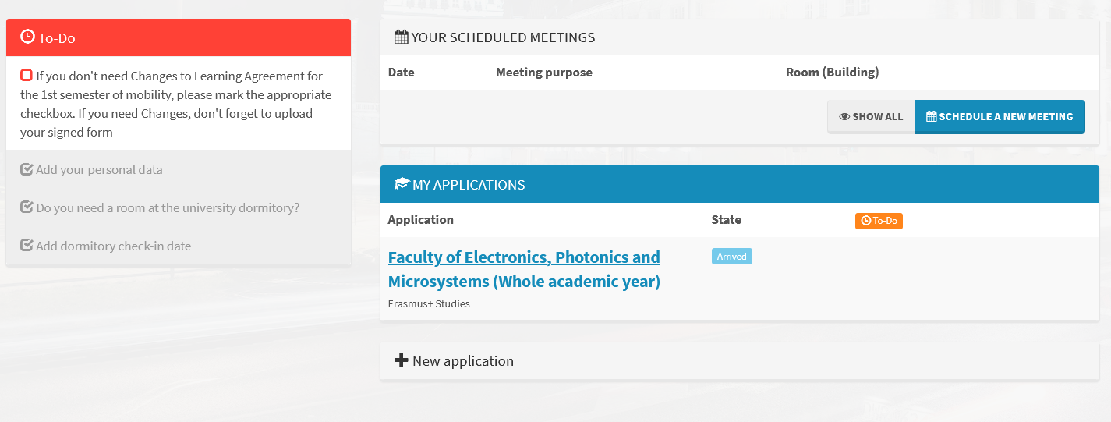
- Click on Changes to LA section
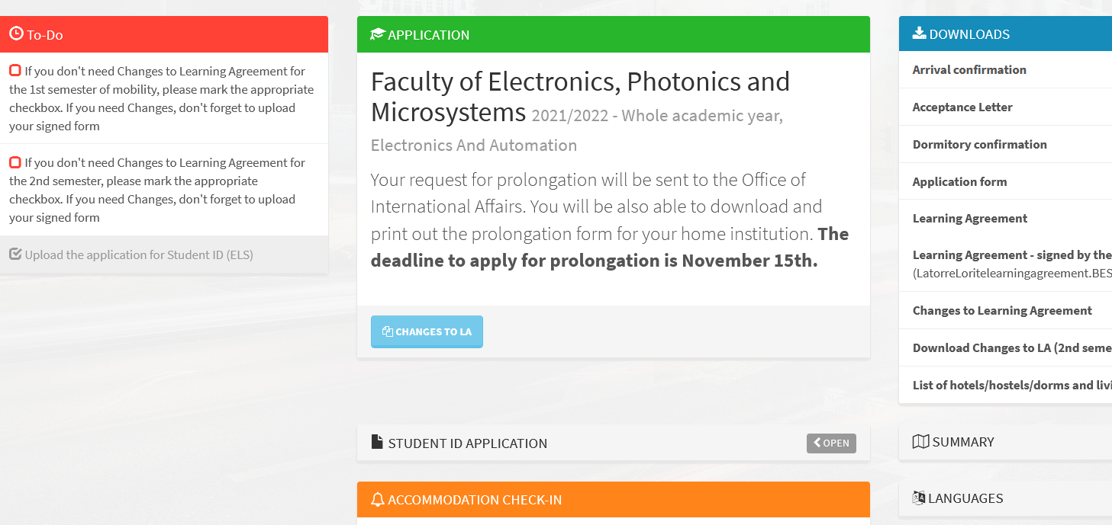
- If you don’t need Changes to LA, please mark the appropriate checkbox.
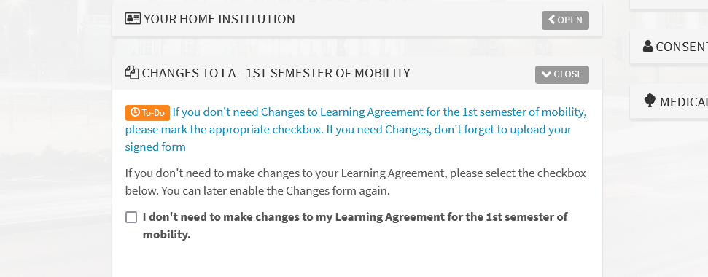

- If you need Changes to LA - please decide at each course (clik on the pen icon) if it stays or is removed (give a reason). You can also add a new course by pressing NEW buton.
Remember to fill the table B, too.
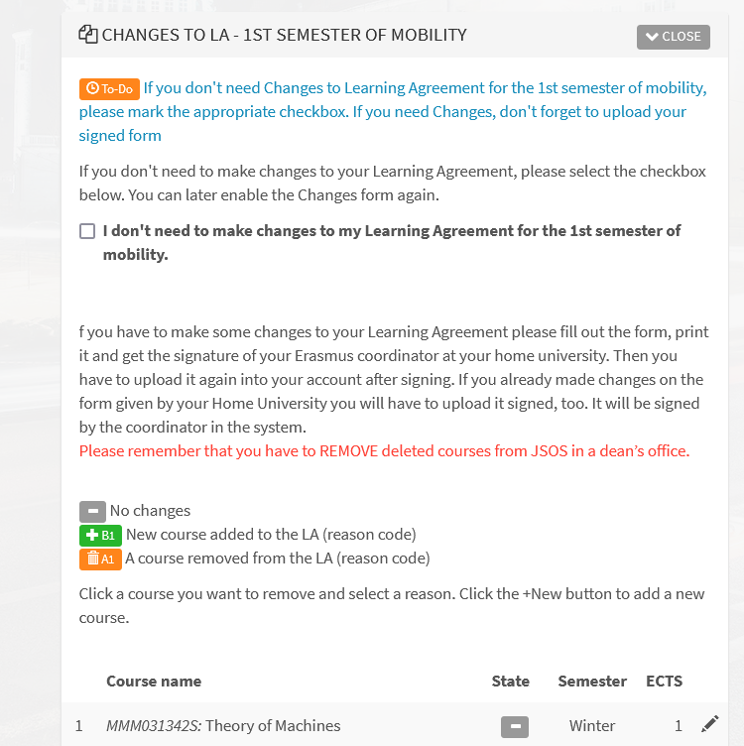
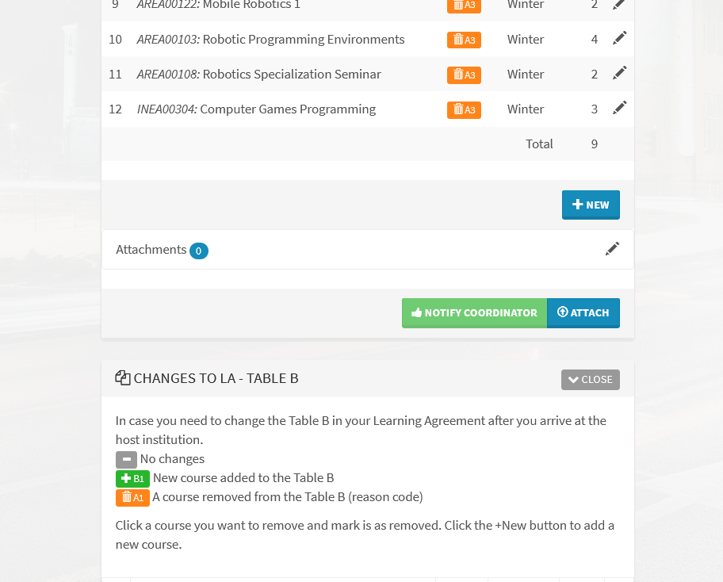

- Download the Changes to LA

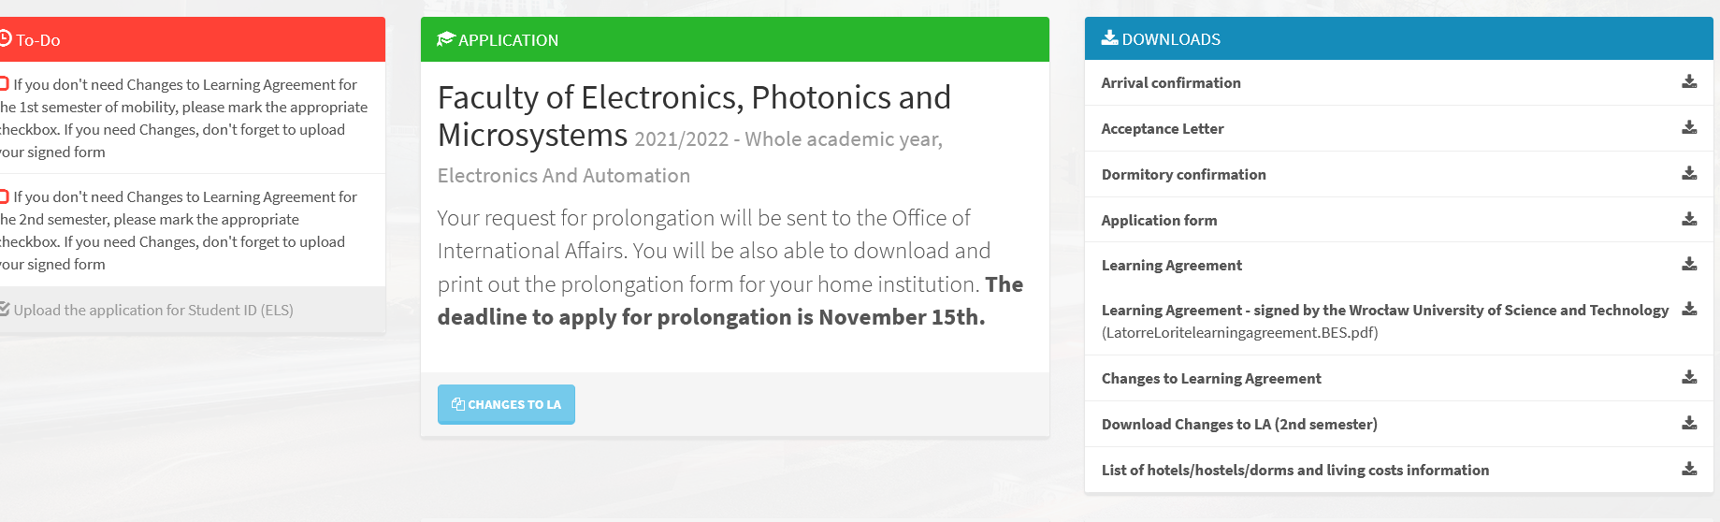

- Sign your ChLA yourself and ask your HOME University coordinator to sign it, too.
- Attach signed ChLA to the IRC system and then notify the coordinator.
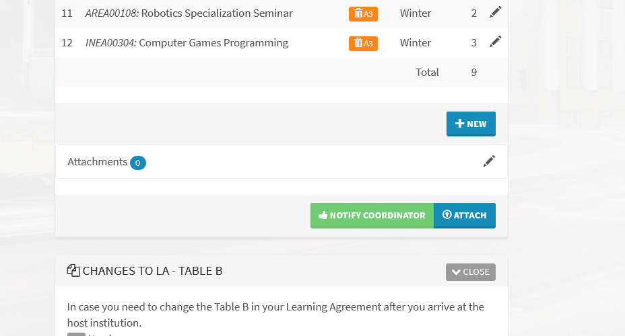
- The WUST coordinator will sign the document and attach it in the IRC system, where you will be able to find it.

