1. **Residence in Wrocław**

I’d like to remind you that if you’re **EU citizen** and you’re staying in Poland longer than 3 months, you are obliged to register your stay in Governor’s Office.

**You can look up more information here:**

<http://dsm.pwr.edu.pl/en/international-students/exchange-erasmus/incoming/erasmus-plus/during-the-mobility>

**The address of the Governor’s Office:**

<https://duw.pl/pl/urzad/informacje-podstawowe/kontakt>

Some important information:

<https://udsc.gov.pl/do-pobrania/materialy-informacyjne-urzedu/>

The confirmation written in Polish that you are an Erasmus Student at WUST can be prepared by international officer.

Please be informed that our **Office of International Relations** is located at:

12 Na Grobli street (you can take Polinka cable car if you travel from Wybrzeże Wyspiańskiego street), approx.3 mins from Polinka cable car **Building L-3, room 1.20**

1. **HOW to GET and PAY for your student ID card?**

Please download Student ID Card (els) – application form from you IRC account, sing it and upload again in the IRC system. It will be automatically sent via e-mail to the relevant dean’s officer.

You have to pay the fee of 22 PLN to your individual bank account which can be found in your JSOS account, where you will also have the possibility pay the fee online, what we strongly recommend.

The deadline for payment is 26/09/2022 to get the student ID card at the beginning of October. If you pay later, the student ID card will be issued later.

You can pay the fee online via your JSOS account as follows:

* Please enter your account at jsos.pwr.edu.pl, choose English language and “Student” box, then log in.

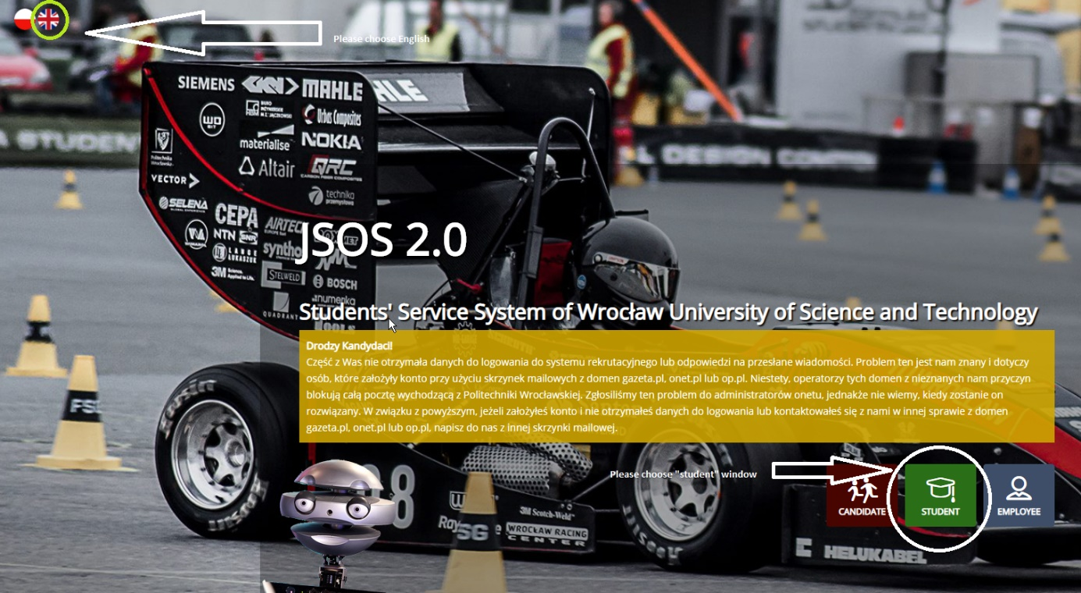

* Please enter the tab “Finances” then “Fees”, where you should tick the checkbox described as “Elektroniczna legitymacja studencka” which means “Electronic student ID card”. Then click PAY button.

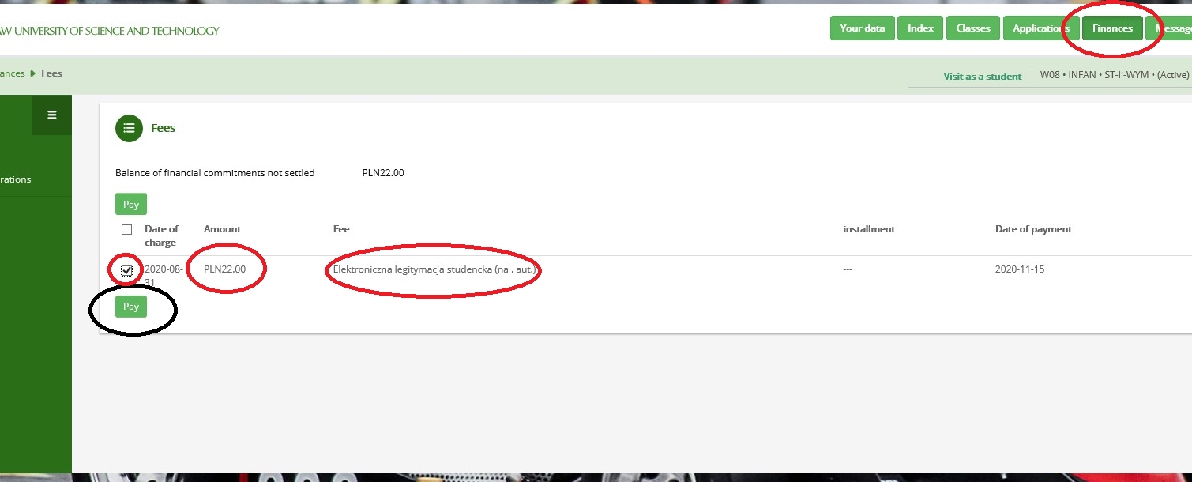

If you pay online, the dean’s office will see your payment registered, then will print your student ID card and will inform you via university e-mail (DO NOT forget to activate your ID student's number) when and how to pick up your Student ID Card. If you face any problems when trying to pay for the ID card via JSOS please contact the Dean’s Office.

If you do not want to pay online, please contact the deans’ office to ask for your individual account number to pay the fee and then send the confirmation of payment to the relevant dean’s officer.

1. **WUST e-mail instruction — GMAIL**

Each student of Wrocław University of Science and Technology has a personal e-mail account.

This account is used as a university’s communicating platform so if you want to receive important information regarding your studies or to be able to generate new passwords for JSOS, don’t forget to active it!

To log in into a new mailbox:

           1. Go to the website [http://poczta.student.pwr.edu.pl](http://poczta.student.pwr.edu.pl/)

           2. Enter the student e-mail address (<StudentID>@student.pwr.edu.pl) and select "Next", where <StudentID> is an individual Student Identification Number assgined after the addmission; for instance: [123456@student.pwr.edu.pl](mailto:123456@student.pwr.edu.pl)

           3. On the next page, click "Forgot your password?"

           4. Then click "Try another way"

           5. The website will propose to send a verification code to a secondary e-mail address. This is the e-mail address provided during recruitment.

           6. A message with a verification code will be sent to the secondary address, which must be entered in the form in the next step

7. Then create a password.

           8. Log in to GMail with your new password.

1. **WUST student mail server**

To **activate** the account please proceed as following:

1. Enter the address: s.student.pwr.edu.pl and choose the English language and section “account activation”:

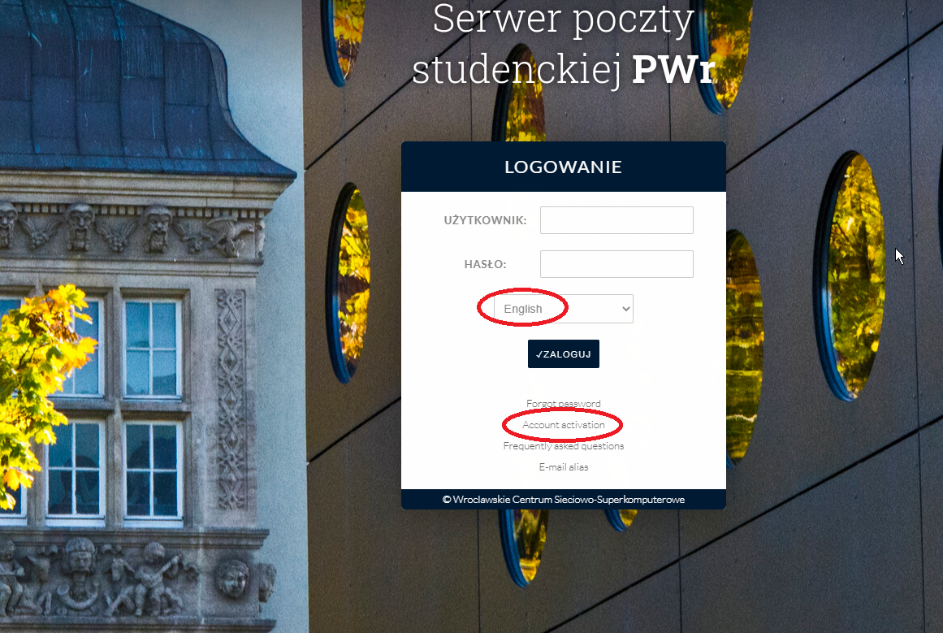

1. Please fill all the requested data **exactly** as you wrote them in your JSOS account while registering (you can also check it at JSOS).

In the field named “PESEL” please write “00000000000” (i.e. “0” eleven times).

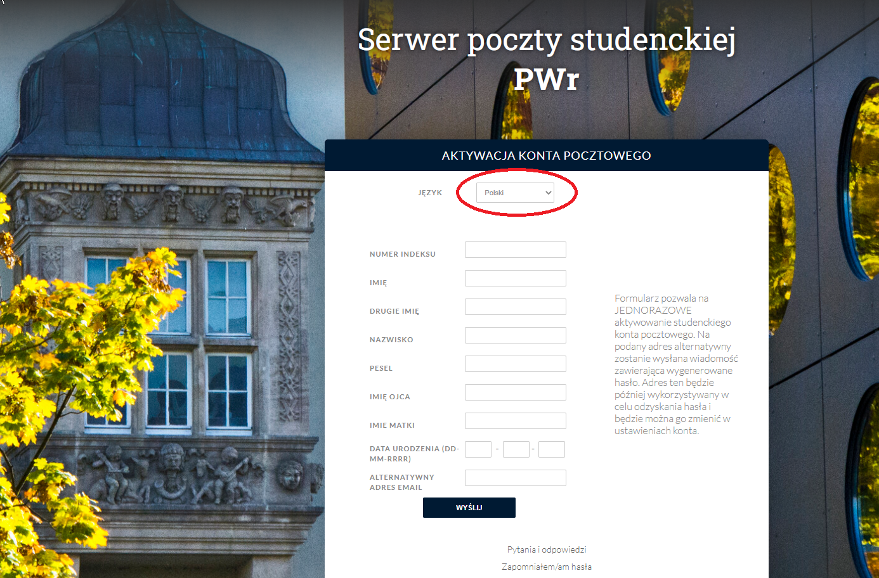

1. After successful registering, you will receive an activation link to your alternative email address.
2. In case of any problems with activation of the e-mail please contact the administrator: [pomoc+jsos@pwr.edu.pl](mailto:pomoc+jsos@pwr.edu.pl)
3. You can log in at the website: s.student.pwr.edu.pl using your student’s ID number and the password.

**5. E – PORTAL INSTRUCTION**

As the student of WUST you have an access to our internal e- learning portal. Some of teachers will ask you to follow courses or additional exercises there, so below we are sending the short instruction about the website.

You can enter E – learning portal through the website: <https://eportal.pwr.edu.pl/?lang=en> which is available in Polish, English and German. To log in, please click “log in” in the right top corner.

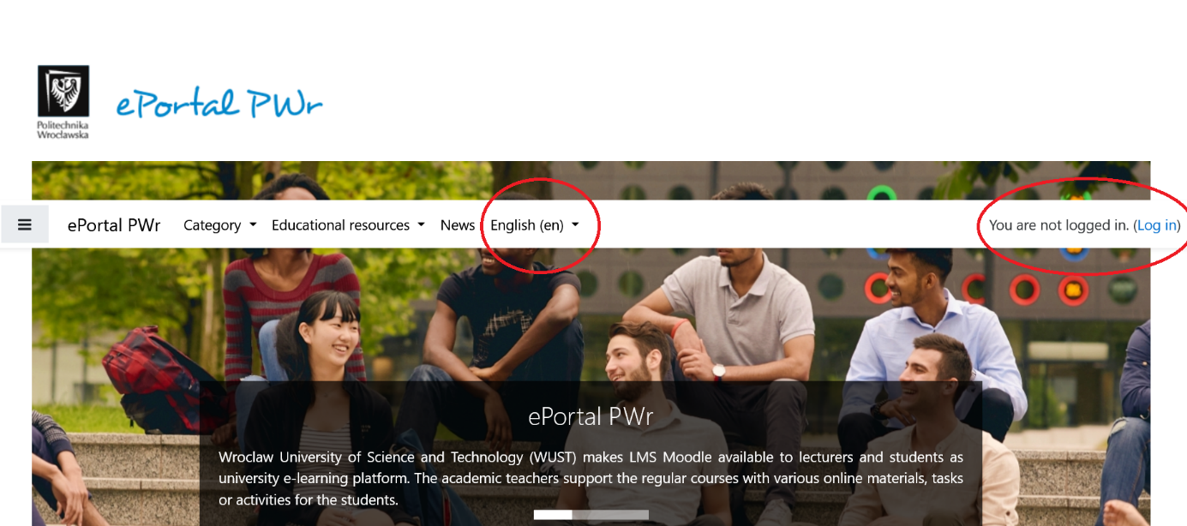

Next you should choose the “JSOS users” option. 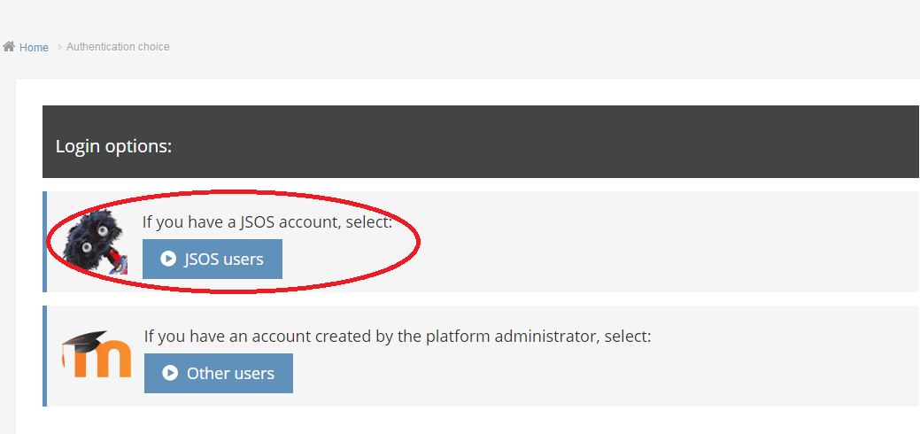 Username and password are the same as for your JSOS account.

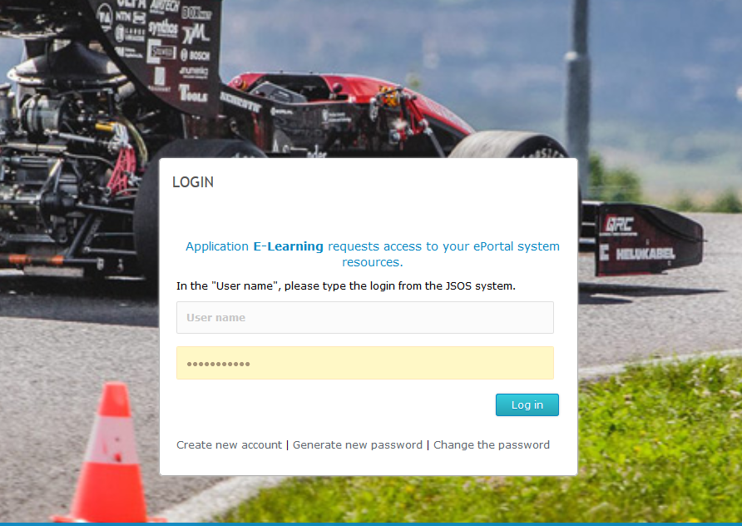

After you log in, you’ll have access to various online courses and additional educational materials, exercises etc. offered for your faculty and the whole University

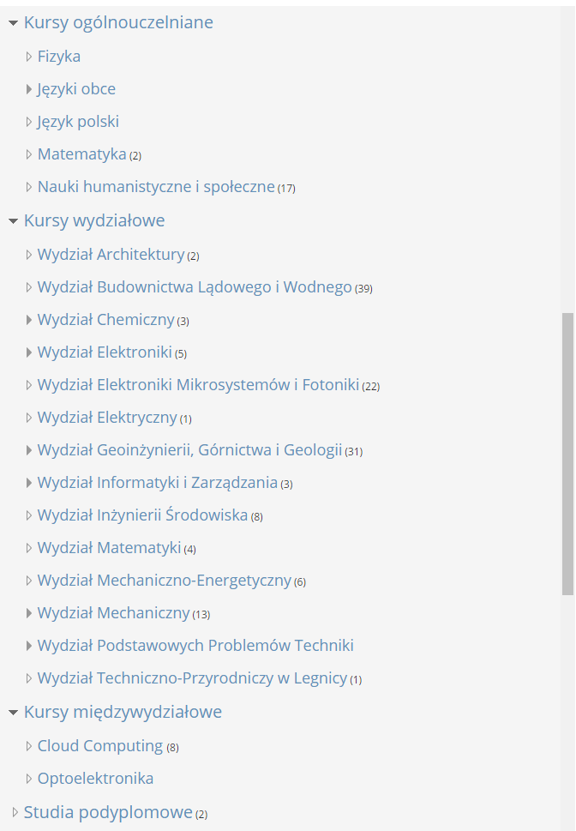

To access some of the courses, you’ll have to register for it beforehand. To do it, please click on “Request a course” icon available below the course data.

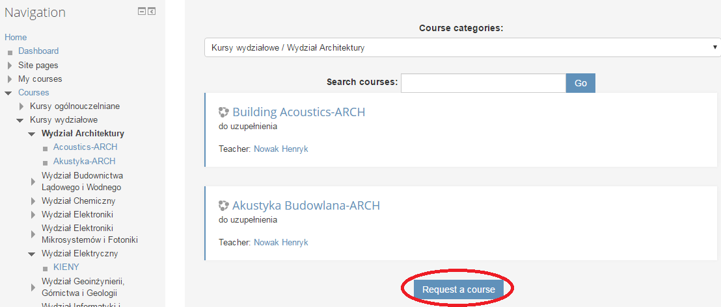

You will have to fill the form:

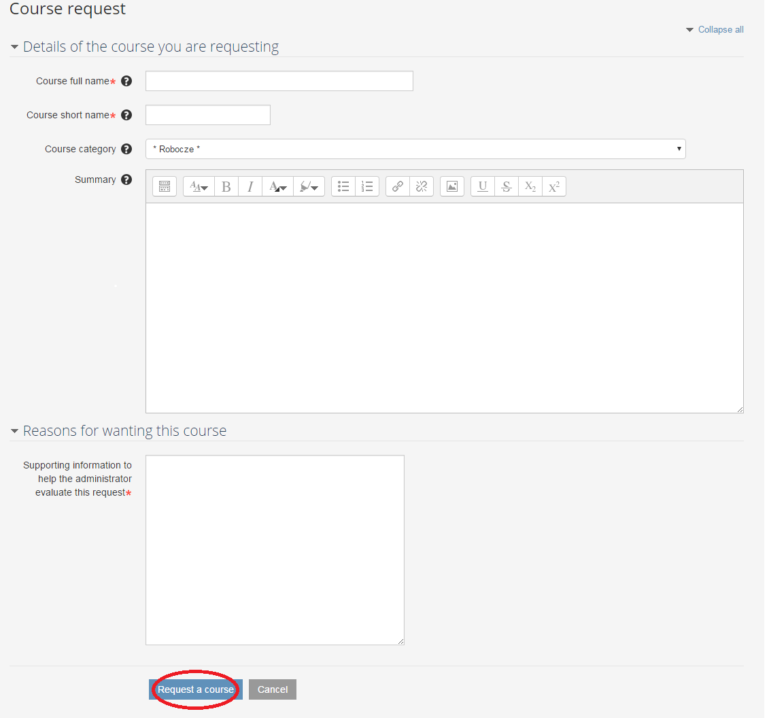You will receive authorization to follow the course to your WUST’s student email.

Enjoy your online materials and good luck!

1. **Health care, hospital**

**EMERGENCY**

In case of emergency you can contact Wrocław emergency departments at one of Wrocław’s hospitals.

**You can seek basic healthcare during night-time (18:00-8:00), weekends and holidays here:**

* **Wojewódzki Szpital Specjalistyczny im. J. Gromkowskiego** **(**[**J. Gromkowski Regional Specialist Hospital**](http://www.szpital.wroc.pl/)**)**  
  ul. Koszarowa 5; 51-149 Wrocław  
  Tel. +48 71 395 76 07
* **Wojewódzki Szpital Specjalistyczny (Regional Specialist Hospital)**ul. Kamieńskiego 73a; 51-124 Wrocław  
  Tel. +48 71 32 70 536
* **Szpital Specjalistyczny im A. Falkiewicza (**[**A. Falkiewicz Specialist Hospital**](http://www.falkiewicza.internetdsl.pl/) **)**ul. Warszawska 2; 52-114 Wrocław  
  Tel. +48 71 37 74 116
* **Dolnośląski Szpital Specjalistyczny im. T. Marciniaka (**[**T. Marciniak Lower Silesian Specialist Hospital - Emergency Medicine Centre**](http://www.szpital-marciniak.wroclaw.pl/index.html)**)**ul. Fieldorfa 2; 54-049 Wrocław  
  Tel. +48 71 306 42 22

**Remember:** Call an **ambulance** only if you are in immediate danger or you have observed sudden, serious deterioration in your health! If this is not the case, you should seek the help of GP.

To call for ambulance call **112** or **999**.

**NFZ information**

Below find below the information about health service and insurance offered by our National Health Found. They are unfortunately in Polish only, but you can try some translators to help you understand it.

<https://www.nfz.gov.pl/aktualnosci/aktualnosci-oddzialow/zasady-leczenia-obcokrajowcow-ktorzy-nie-sa-ubezpieczeni-w-polsce,398.html>

<https://www.nfz.gov.pl/dla-pacjenta/zalatw-sprawe-krok-po-kroku/jak-ubezpieczyc-sie-dobrowolnie/>